

J.E. CAIRNES SCHOOL OF BUSINESS & ECONOMICS
END-OF-MODULE ASSIGNMENT (PART B)
VALUE IN ANALYTICS
Module Code | MS5106
Student Name and ID | AMIT KUMAR - 24236930

In submitting this assignment, I am aware that it is my responsibility to adhere to the submission guidelines. Please tick (double click… or Yes/No) for the following:

 | Yes | No
I am aware of what the University of Galway plagiarism policy entails.
I have named the assignment file (MS Word docx or doc) to contain my student ID and the module code and assignment number (e.g., 24236930_MS5106_A1.docx).

Declaration for this Assignment Submission:
“In submitting this work I confirm that it is entirely my own. I acknowledge that I may be invited to undertake an online interview if there is any concern in relation to the integrity of my submission.”
Table of Contents
Store layout 3
Question A 3
How would you leverage the given Wi-Fi data to extract actionable insights and create more value? 3
1. Business Value from Wi-Fi Analytics 3
2. Customer Value from Wi-Fi Analytics 5
3. Conclusion 5
Question B 5
How would you leverage the RFID data to extract actionable insights and create more value? 5
1. Business Value from RFID Merchandise Analytics 6
2. Customer Value from RFID Innovation 8
3. Conclusion 8
Question C 9
Do you think these third party data would assist the company in further creating value? 9
1. Business Value from POI Data 9
2. Customer Value from POI Integration 10
3. Conclusion 10
References 11

Store layout
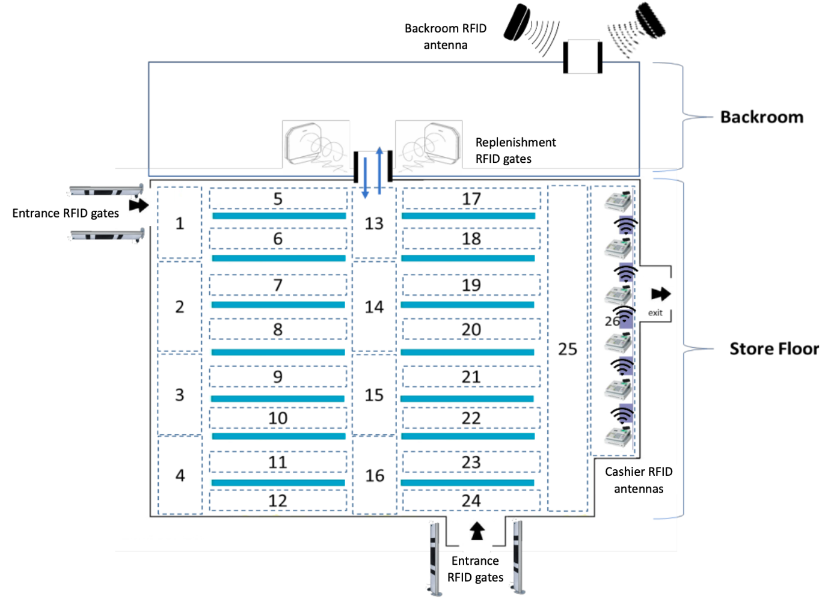
Figure 1 - Store layout

Question A

How would you leverage the given Wi-Fi data to extract actionable insights and create more value?
PriMarket’s in-store Wi-Fi system uses 26 access points spread throughout the shop floor (Areas 1–26), which can provide the ability to track customer movement through various departments and aisles. This system can records when a customer’s device connects to each Wi-Fi router, enabling the reconstruction of visit patterns, dwell times, and flow paths. When integrated with the loyalty app, this data becomes even more powerful for analysis and personalization.

1. Business Value from Wi-Fi Analytics
The Wi-Fi router layout enables precise zone-by-zone heatmapping and behavioural segmentation. For instance, routers in Areas 1 and 4 (near entrances) and Area 26 (near exit) capture customer entry and exit activity. Routers in central aisles track movement between departments.
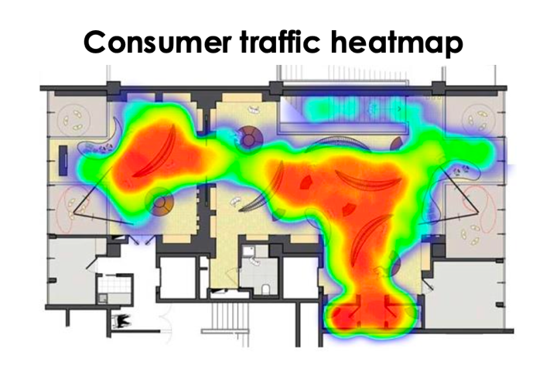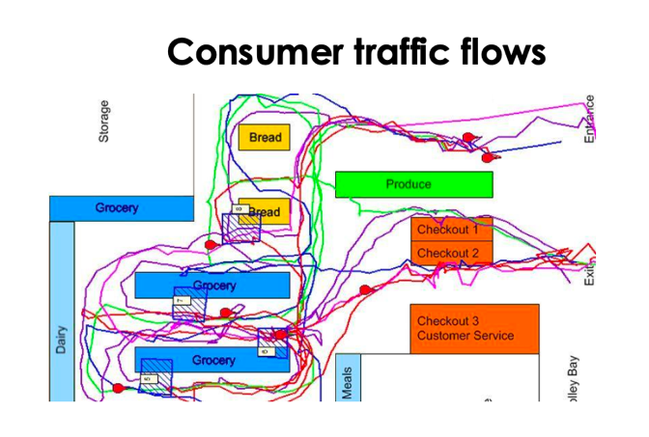
Figure 2 - Customer Traffic Heat Map And Flow [2]
By aggregating customer paths, PriMarket can develop foot traffic heatmaps and identify underperforming zones. If Areas 9–12 show low visit counts while adjacent areas (e.g., Areas 5–8) are busy, it may indicate poor signage, product placement, or customer disinterest in that section. Management could respond by rotating product displays, updating promotions, or improving visibility.
Similarly, dwell time metrics help flag issues. For example, if Area 13 (in the centre aisle) has long dwell times but low conversion (via linked loyalty data), this could indicate customer interest but friction in completing the sale, perhaps due to pricing, cluttered displays, or poor stock levels. By targeting such areas for layout reconfiguration or price adjustments, PriMarket can optimize conversions.
Customer flow patterns also emerge from Wi-Fi traces. For example, customers might frequently move from Area 7 to Area 19. Recognizing this common path, PriMarket can redesign the store to promote complementary products nearby (e.g., placing belts near trouser zones for add-on sales). Understanding flow also helps manage congestion, if Areas 13–14 become crowded between 5–7 PM, PriMarket can increase stock or redistribute popular items to balance footfall.
As Larson revealed that customer shopping paths are not random and can be clustered into typical route patterns [1]. Wi-Fi data allows PriMarket to uncover such behavioral patterns in its own store and respond accordingly.

2. Customer Value from Wi-Fi Analytics
For customers, these analytics support a smoother, faster, and more enjoyable shopping journey. By addressing low-flow or high-friction areas, customers can navigate the store more easily and find what they’re looking for without frustration.
Moreover, when customers log in through the loyalty app, their location history can be used for personalized real-time offers. For instance, a customer dwelling in coats Area could receive a notification offering 10% off on outerwear. This improves engagement and makes shopping feel more relevant and rewarding.
Wi-Fi analytics also support better product availability. If customers frequently linger in a department but fail to buy, this may indicate that popular sizes or styles are missing. By responding to such data, PriMarket ensures stock aligns with interest, avoiding missed sales and enhancing customer satisfaction.

3. Conclusion
By leveraging its area-based Wi-Fi infrastructure, PriMarket can extract detailed behavioural insights that drive operational improvements, smarter layouts, and more tailored promotions. For customers, this results in a better organized, more responsive store that enhances satisfaction and encourages repeat visits.

Question B

How would you leverage the RFID data to extract actionable insights and create more value?
RFID (Radio-Frequency Identification) technology is integrated into PriMarket’s store through garment tagging and fixed antennas positioned at critical transition points backroom, replenishment gates, entrance/exit gates, and cashier desks. These placements allow the store to track merchandise flow through its journey from storage to sale or exit. This real-time tracking of product movement provides a rich data source for both operational intelligence and customer experience enhancement.

1. Business Value from RFID Merchandise Analytics
The strategic placement of RFID readers at key store nodes enables PriMarket to develop a flow-based view of inventory. By analysing timestamps at each gate, managers can reconstruct product journeys and derive insights about stock efficiency and operational gaps.
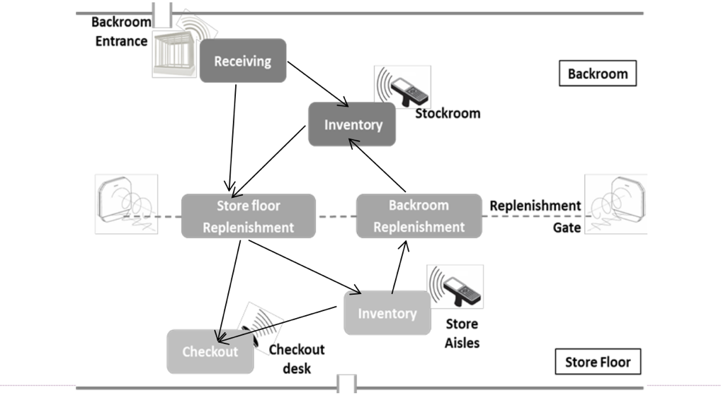
Figure 3 - RFID Setup in Store [2]
Inventory Management is the most immediate gain. Since all garments are tagged, PriMarket has accurate, real-time visibility into what is stored in the backroom, what is available on the sales floor, and what has been sold or possibly stolen. For instance, if a product passes the replenishment gate but is never scanned at the cashier or exit, it may still be on display or could be misplaced. This can trigger alerts for restocking, minimizing stockouts and optimizing replenishment cycles.
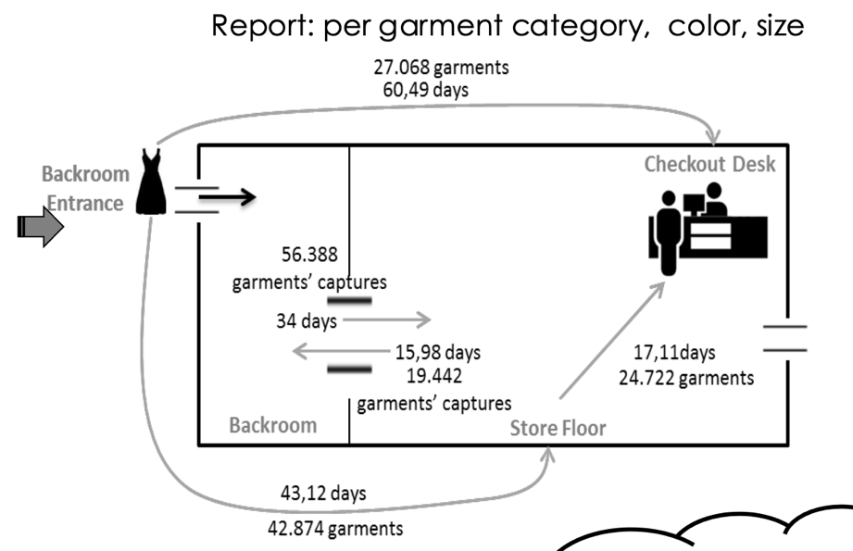
Figure 4 - Inventory Management Using RFID [2]
RFID data also supports product lifecycle tracking. If a new summer dress spends an average of 2 days between replenishment and cashier, it is a fast-moving item, indicating strong demand. Conversely, slow movers can be flagged for markdowns, repositioning, or promotional bundling.
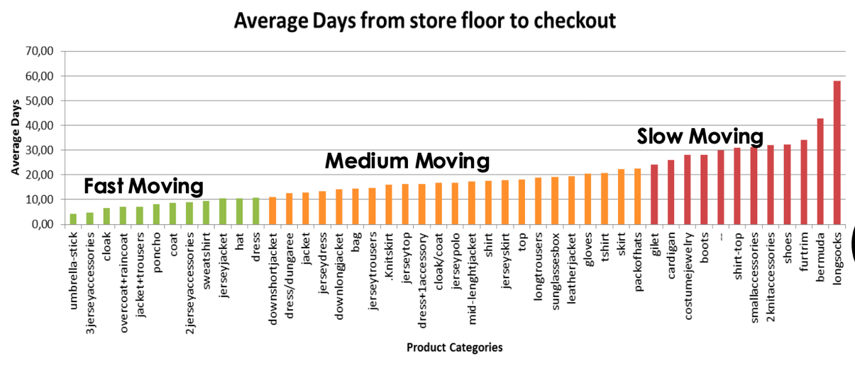
Figure 5 - Product Lifecycle Tracking [2]
As Griva introduced two helpful metrics, volume and mobility to describe object flow within a network like this. Applied here, volume represents how many garments pass between zones (e.g., backroom to sales floor), while mobility measures frequency and diversity of transitions [3]. High volume with low cashier reads might indicate inefficient replenishment, high mobility with few sales might reflect disorganized floor layouts (e.g., customers moving items around without buying).
Loss prevention is another key benefit. RFID antennas at exits compare all outgoing tagged items with cashier logs. Any tag detected at the exit but not recorded at checkout indicates potential theft or system error.
Operational auditing also becomes more efficient. Store managers no longer need manual shelf checks, as RFID data provides real-time stock counts by area.
A valuable improvement would be Installing RFID antennas in fitting rooms helps track try-ons, revealing conversion gaps, fit issues, or theft risks, enabling PriMarket to refine products, detect losses, and enhance customer understanding.

2. Customer Value from RFID Innovation
From the customer’s perspective, RFID delivers stock reliability and checkout speed. Accurate tracking ensures products are available in the right size and colour, avoiding frustration. A customer browsing for a jacket will likely find the item if RFID data indicates sufficient stock and staff can verify instantly using handheld readers.
Checkout is also faster. The cashier RFID antennas allow multi-item scanning in seconds, compared to traditional barcode scanning. This reduces queuing time and enhances convenience.
RFID also enables automated self-checkout or mobile scanning as done by Amazon. Combined with Wi-Fi analytics, it can eventually allow personalized alerts (e.g., “Your preferred item is now restocked”), enhancing engagement.

3. Conclusion
The RFID system illustrated in the store layout creates a powerful real-time tracking infrastructure that supports efficient stock management, loss reduction, and sales insights. It simultaneously enhances customer satisfaction by ensuring availability and convenience.

Question C

Do you think these third party data would assist the company in further creating value?
Yes, third-party data from a mobile location-based app like TrackApp can greatly assist PriMarket in creating additional value. The data captures customer’s out of store behaviour by logging check-ins and check-outs at various Points of Interest (POIs) such as competitor stores. When ethically and legally collected, this data provides context beyond in-store activity, enhancing ability to understand and serve its customers better.

1. Business Value from POI Data
TrackApp data enables customer profiling, revealing where customers spend time outside and offering insights into their lifestyles, preferences, and routines. For instance, if a significant portion of loyalty customers also check in at premium fashion boutiques, it may indicate a preference for higher end styles. PriMarket can respond by expanding its premium product line or emphasizing quality in marketing campaigns.
Alternatively, if customers frequently visit discount fashion chains, PriMarket might consider pricing adjustments or value-oriented promotions to remain competitive. This competitive intelligence can be a key strategic asset. It allows to identify churn risks, adjust branding, and fine-tune its positioning in the market.
In addition, POI data reveals opportunities for geographic expansion and store planning. For example, if many loyal customers check in at suburban malls where PriMarket has no presence, it signals potential for launching a new outlet, pop-up store.
TrackApp can also support strategic partnerships and co-promotions. If customers frequently check in at a nearby coffee chain or cinema, PriMarket could initiate cross-brand campaigns such as a discount at PriMarket for customers who visit partnered venues. This increases foot traffic and creates brand affinity through lifestyle integration.
As noted by Bianchini, location intelligence enables brands to act on external behavioural cues, tailoring offers based on where consumers live, work, and socialize [4]. TrackApp functions as a predictive and reactive marketing tool, signalling when to engage a customer segment, how to segment more accurately, and when to intervene to prevent churn.

2. Customer Value from POI Integration
For customers, POI-driven insights lead to greater personalization and convenience. If PriMarket recognizes that a shopper often visits fitness centres and outdoor gear stores, it might showcase athletic wear or hiking outfits in that person’s loyalty app feed. Someone who visits restaurants and nightlife venues could be targeted with promotions for partywear or stylish evening apparel.
Moreover, POI analysis may result in improved service coverage, such as placing stores or delivery hubs closer to residential zones.
Additionally, cross-promotional rewards based on lifestyle habits make loyalty more meaningful. For example, a customer could receive a free coffee from a partner cafe after a purchase at PriMarket encouraging repeat business and emotional connection to the brand.
As Precisely highlights, leveraging POI data helps retailers “align products and messaging with the places and interests their customers already care about” [5], making engagement feel more personal and less intrusive.

3. Conclusion
TrackApp provides PriMarket with a window into customer lives beyond the store. When combined with internal data (Wi-Fi, RFID, purchase records), it enables targeted marketing, strategic expansion, and service innovation. For customers, this translates into personalized, context-aware offers and enhanced convenience ultimately boosting loyalty and satisfaction.

References
[1] Larson, J. S., Bradlow, E. T., & Fader, P. S. (2005). An exploratory look at supermarket shopping paths. International Journal of Research in Marketing
[2] Griva, A. (2024) Creating value with analytics: Using satisfaction data from e-commerce. Lecture notes, MS5106 Data Science and Big Data Analytics, University of Galway
[3] Griva, A., Bardaki, C., Pramatari, K., & Doukidis, G. (2016). Mapping moving object events into a network of object flows to support decisions. ECIS Proceedings.
[4] Bianchini, C. (2022). How location data helps marketers acquire new customers and expand campaigns. MarTech.
[5] Precisely. (2022). The Power of Where: 5 Use Cases for Retail Location-Based Data. Precisely Blog.

